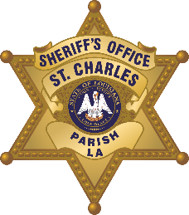

St. Charles Parish Sheriff’s Office
Public Information
260 Judge Edward Dufresne Parkway, Luling, LA 70070
Voice (985) 783-1280 • Fax (985) 783-1138

Greg Champagne
Sheriff

N e w s R e l e a s e
January 8, 2026
Drug Arrests
Anyone with information regarding this incident(s) is asked to call Crime stoppers at 1-877-903-STOP. Citizens do not have to give their name nor testify and could receive up to $2,500.

ARRESTEE: | Griffin, Donquiel W., 25, 19315 Providence, Hammond, LA
LOCATION: | Paul Fredrick St. Luling, LA
DATE: | 1/6/26
ITEM NO.: | 2505088
CHGS: Dist. Of Cannabinoids/Synthetic Marijuana, Poss. Of Tapentadol Hydrochloride
The St. Charles Parish Sheriff’s Office reports Griffin was arrested after allegedly being found in possession of illegal narcotics. Griffin was arrested and booked accordingly.

